Full PRD — Business Website Gap Finder

1) Overview
Problem: Small businesses without websites are hard to identify, so outreach teams waste time searching manually.
Solution: A web app that finds local businesses and flags which ones lack a website.

2) Goals
- Let users discover under-digitized local businesses fast.
- Provide a demo-ready workflow with clear, repeatable results.
- Reduce cost and latency with caching.

3) Non-Goals
- Full CRM or outreach automation.
- Replacing paid map platforms.
- Perfect accuracy for every website check.

4) User Personas
1. Local marketing agency — needs outreach lists.
2. Business directory owner — wants to identify gaps.
3. Startup founder — validates a lead-gen workflow.

5) Core User Flows
Flow A: Run a search
1. User enters a prompt (e.g., "Find salons in Chicago without websites").
2. App extracts business type + location (Gemini or mock).
3. OpenStreetMap returns matching businesses.
4. Mino checks each business for website presence.
5. Results are shown and cached.

Flow B: Repeat a search
1. User runs the same prompt again.
2. Supabase cache is checked first.
3. Recent results return quickly without re-checking.

6) Functional Requirements
- Prompt input (text area + submit button).
- Loading and error states.
- Summary stats (total businesses + count without websites).
- Results table (name + address + website status).
- Quick prompt buttons for common categories.
- Optional status pills (Gemini, OSM, Cache, Mino).

7) Technical Architecture
Frontend (Next.js App Router):
Takes prompt → calls `/api/run` → renders results.

Backend (Next.js API route):
1. Extract business type + location (Gemini or mock).
2. Call OpenStreetMap (Nominatim).
3. For each business:
- Check Supabase cache
- If stale or missing → call Mino
- Save result back to Supabase
4. Return formatted JSON.

8) System Diagram
flowchart LR
User[User] --> UI[Next.js UI]
UI --> API[/api/run]
API --> Gemini[Gemini or Mock Parser]
API --> OSM[OpenStreetMap Nominatim]
API --> Cache[Supabase Cache]
API --> Mino[Mino API]
Mino --> API
Cache --> API
API --> UI

9) Request Sequence Diagram
sequenceDiagram
participant U as User
participant UI as Next.js UI
participant API as /api/run
participant G as Gemini or Mock
participant O as OpenStreetMap
participant C as Supabase Cache
participant M as Mino API
U->>UI: Enter prompt
UI->>API: POST /api/run
API->>G: Parse business + location
API->>O: Search businesses
O-->>API: Business list
loop For each business
API->>C: Cache lookup
alt Fresh cache
C-->>API: Cached result
else Missing or stale
API->>M: Check website
M-->>API: has_website
API->>C: Write result
end
end
API-->>UI: JSON results
UI-->>U: Render table

10) Search Flowchart
flowchart TD
A[User prompt] --> B[Parse business type + location]
B --> C[Search via OpenStreetMap]
C --> D{Business found?}
D -- No --> Z[Return empty results]
D -- Yes --> E[Check cache]
E --> F{Fresh cache?}
F -- Yes --> G[Use cached result]
F -- No --> H[Check website via Mino]
H --> I[Write back to cache]
G --> J[Aggregate results]
I --> J
J --> K[Return JSON to UI]

11) Swimlane Flow (Roles)
flowchart LR
subgraph Client
U[User]
UI[Next.js UI]
end
subgraph Server
API[/api/run/]
end
subgraph Services
G[Gemini or Mock]
O[OpenStreetMap]
M[Mino]
C[Supabase]
end
U --> UI --> API
API --> G --> API
API --> O --> API
API --> C --> API
API --> M --> API
API --> UI --> U

12) Cache Decision Flow
flowchart TD
A[Business record] --> B{Exists in cache?}
B -- No --> C[Call Mino]
B -- Yes --> D{Last checked < 24h?}
D -- Yes --> E[Use cached has_website]
D -- No --> C
C --> F[Save result + timestamp]

13) APIs Used
1. OpenStreetMap (Nominatim)
- Purpose: Find businesses by query
2. Mino API
- Purpose: Visit pages and detect website links
3. Supabase
- Purpose: Store and reuse results

14) Data & Storage
- Table: `businesses`
- Fields: `name`, `place_id`, `has_website`, `last_checked_at`
- Cache rule: If data is less than 24 hours old, reuse it.

15) Error Handling
- Gemini unavailable → fallback to mock parser.
- OpenStreetMap failure → return empty results with error messaging.
- Mino failure → mark `has_website = false` and continue.
- Supabase failure → return results without caching.

16) Mocking Strategy (Demo Mode)
- Gemini parsing is mocked to keep demos stable without billing.
- Location is extracted with a simple heuristic.
- Default location is applied if none found.

17) UI/UX Requirements
- Clear headline explaining the app's purpose.
- Example prompts (US cities + categories).
- Visible "Ready to search" status.
- Friendly empty state and error state messages.
- Results table with readable spacing.

18) Success Metrics
- Time to first result < 10 seconds (cached < 3 seconds).
- 80%+ user understanding from the first screen.
- Fewer than 1 error per 20 runs.

19) Risks & Mitigations
- Mino timeouts: enforce a safe timeout and retries.
- False positives: rely on cache freshness and re-check stale data.
- Quota limits: keep mock mode available for demos.

20) Future Improvements
- Enable live Gemini parsing (billing).
- Add category filters (e.g., "only restaurants").
- Export CSV.
- Save searches and histories.

21) Links
- Live App: https://aaa-new-webapp-chatgpt-cursor.vercel.app
- Repo: https://github.com/Aditya-729/Automated-Detection-of-Google-Maps-Businesses-Without-Websites
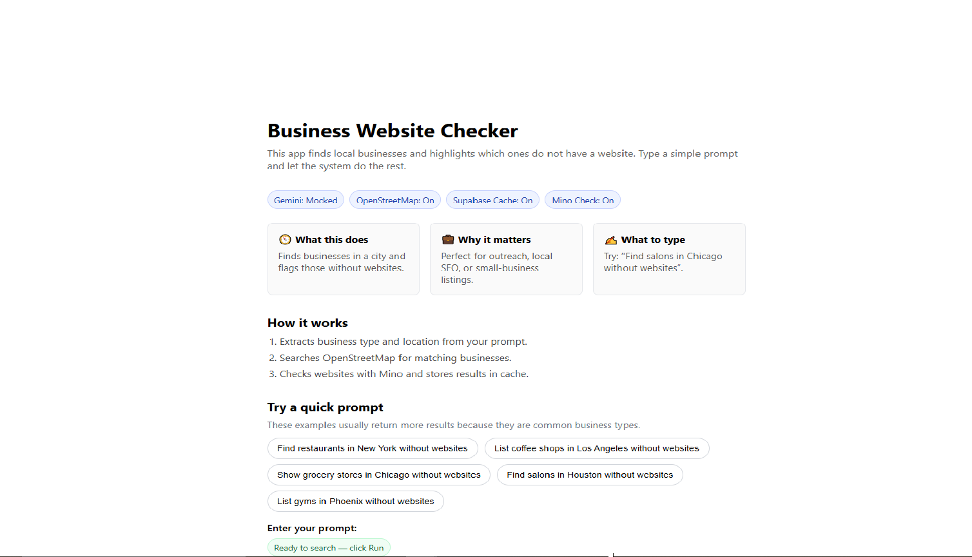
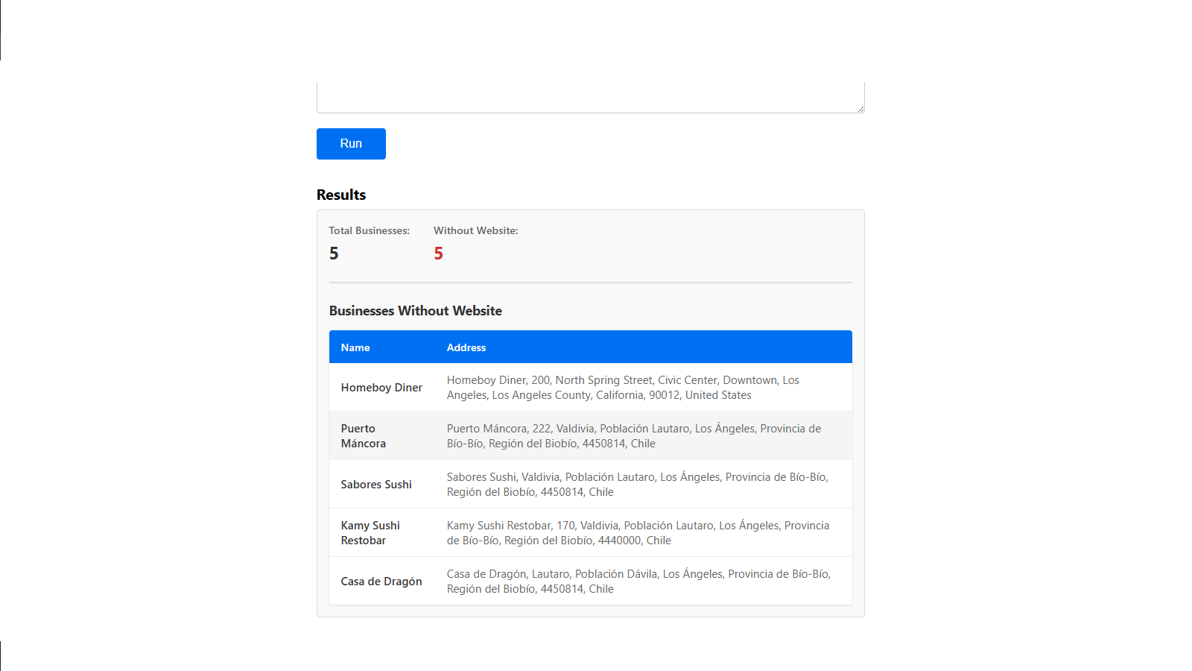
- Screenshots:
